Clustering results:
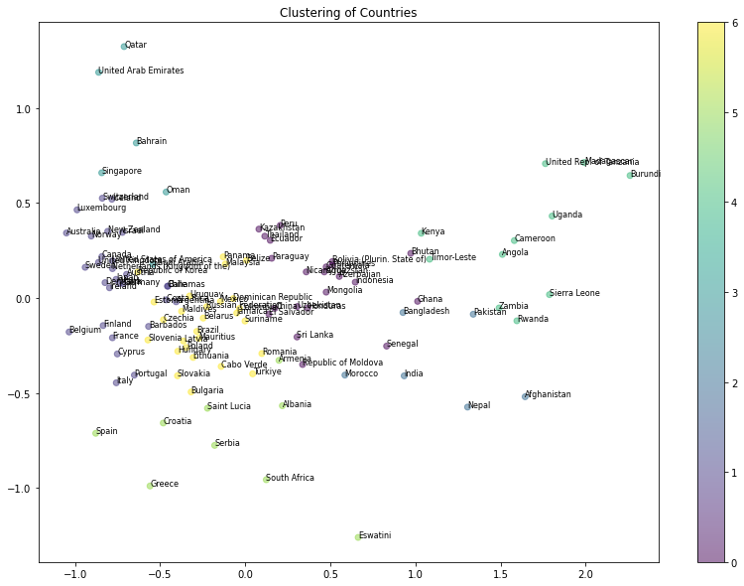I used the elbow method to determine the best number of PCs and clusters, but there wasn’t a super clear elbow for # of clusters (probably suggesting that the data doesn’t cluster terribly well – you can see that from the graph). I just used K-means clustering, but other methods like DBScan or GMMs might work better on the data.
For linear regression, I had manually removed all the highly collinear variables (using VIF), but here I thought PCA would be the best way to remove collinearity.
Top 5 variables for PC1:
Employment by industry: Services (%) Female 0.230846
Employment by industry: Agriculture (%) Female 0.230600
Employment by industry: Agriculture (%) Male 0.221293
Employment by industry: Agriculture (%) Male and Female 0.219502
Life expectancy at birth for females (years) 0.214420
Name: PC1, dtype: float64

Top 5 variables for PC2:
Unemployment rate - Male 0.172462
Unemployment rate - Total 0.157261
Unemployment rate - Female 0.136935
Labour force participation - Total 0.134436
Labour force participation - Male 0.121550
Name: PC2, dtype: float64

Top 5 variables for PC3:
Employment by industry: Industry (%) Female 0.174827
Employment by industry: Industry (%) Male and Female 0.108145
Labour force participation - Female 0.085183
Unemployment rate - Male 0.084068
Seats held by women in national parliament, as of February (%) 0.082891
Name: PC3, dtype: float64

Top 5 variables for PC4:
Public expenditure on education (% of GDP) 0.110606
International migrant stock: Male (% total Population) 0.097023
International migrant stock: Both sexes (% total population) 0.091119
Unemployment rate - Female 0.082851
Domestic general government health expenditure (% of total government expenditure) 0.082396
Name: PC4, dtype: float64

Top 5 variables for PC5:
Employment by industry: Agriculture (%) Female 0.085449
Employment by industry: Services (%) Female 0.074666
Life expectancy at birth for males (years) 0.066247
Intentional homicide rates per 100,000 0.058322
Life expectancy at birth for both sexes (years) 0.056690
Name: PC5, dtype: float64
Final distribution test for continuous distributions (GDP data):
Summary statistics of your data:
Your data has a mean of 512911.2604651163 , a median of 60672.0 , and a mode of 197.0
Your data has a range of 18205826.0 and variance of 2598151308985.95
The standard deviation is large compared to the mean, indicating a large spread in the data.
Your data is highly positively skewed.
The following data points are outliers:
9 1301097.0
10 1245248.0
30 2208838.0
31 1802212.0
41 1617267.0
42 1556129.0
45 6087188.0
46 11061570.0
71 2642610.0
72 2438208.0
74 3396354.0
75 3356236.0
87 1669620.0
88 2146759.0
90 860854.0
95 2134018.0
96 1835899.0
99 4444931.0
122 1057801.0
123 1171870.0
131 846555.0
154 1144067.0
155 1465773.0
160 1363482.0
182 1420722.0
183 1195676.0
198 864314.0
203 2491397.0
204 2934858.0
207 18206023.0
Name: GDP in current prices (millions of US dollars), dtype: float64
The data is leptokurtic (has positive kurtosis)
Based on the skew and kurtosis, your data does not appear to be normally distributed.
Let's perform a statistical test to learn more about the normality of your dataset.
Based on this test, your data does not appear normally distributed.
Let's see what distributions your data could have been drawn from.
The following distributions match your data: Pareto

Final distribution test for categorical data (status descriptions of crime reports):
Your data is unimodal.
Most frequently occurring category or categories:
Invest Cont
You have 1 categories with 762340 item(s)
You have 1 categories with 104682 item(s)
You have 1 categories with 83373 item(s)
You have 1 categories with 3139 item(s)
You have 1 categories with 1799 item(s)
You have 1 categories with 6 item(s)
Let's see what distributions your data could have been drawn from:
No distributions match the data.

Continuous distributions:
In my code, I created a function that returns possible distributions for continuous data. The function iterates through all possible distributions, determines the appropriate parameters for the distribution from the data, and then creates an “expected” dataset given those parameters. The expected dataset is compared to the actual dataset through either the Anderson-Darling, Shapiro-Wilk, or Kolmogorov-Smirnov test (depending on the distribution) and a list of all possible distributions are printed (a distribution is possible if the test’s p-value is greater than .05). I just tested 10 common distributions, but I think those would be sufficient.
I tested this code on some continuous data from my gdp dataset as well as 15, 100, and 1000 datapoint random samples that are drawn from various distributions. The code almost always (with one exception I believe) returns the correct distribution, though it sometimes returns other distributions as well. These distributions make sense when looking at the histograms, however.
GDP in current prices:
The following distributions match your data for column GDP in current prices (millions of US dollars): Pareto
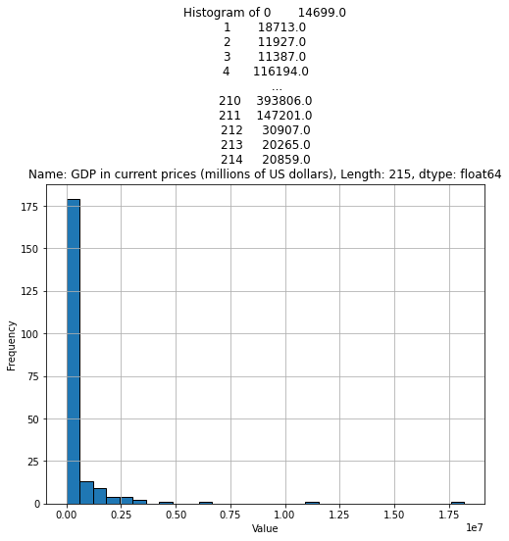Actual data – pretty clearly follows a Pareto distribution.
LLM output:
https://chatgpt.com/share/8f4621b6-436c-48d6-b9ca-4ae13ba6d169
ChatGPT:
- Says the best option would be a log-normal distribution – with pretty extreme parameters, this could be true (log-normal wasn’t one of my distributions, though), didn’t test Pareto
Copilot:
- Describes as a right-skewed leptokurtic distribution, just by analyzing skewness and kurtosis. This is accurate and something I can add to my code but doesn’t describe whether the dataset is drawn from a specific distribution.
Julius:
- Also says log-normal distribution is best
Current health expenditure (% of GDP):
The following distributions match your data for column Current health expenditure (% of GDP): Gamma, Beta, Chi Squared, Weibull, T Distribution
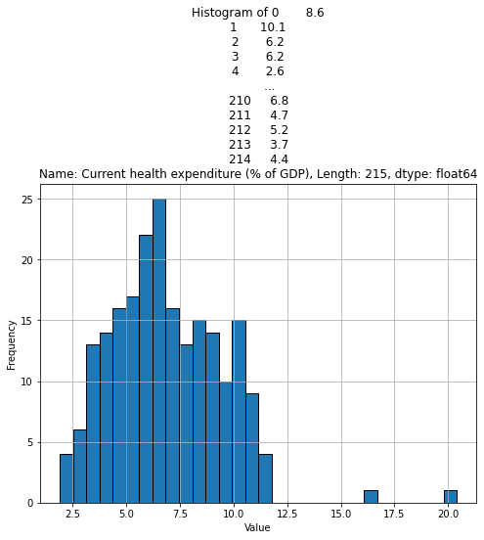Actual data – I’d say all of the distributions predicted could be valid options depending on the parameters provided.
LLM output:
https://chatgpt.com/share/8f4621b6-436c-48d6-b9ca-4ae13ba6d169
ChatGPT:
- Performs these tests using K-S – Anderson-Darling has better statistical power, so I used that one in my code
- Does not test all distributions that I did but says Normal, Weibull, Gamma, and Log-Normal could be good fits. The difference between my predictions and Chat’s (I did not predict a normal distribution) could be due to the use of Anderson-Darling vs. K-S test. If the two outliers were not present, this data could follow a normal distribution.
Copilot:
- Performs normality tests, once again analyzes skewness and kurtosis
- Could not run the code to test other distributions but provides information about potential models given what we already know about the data. These descriptions make sense with what we know about the model
Julius:
- Once again, Log-Normal, Normal, Gamma, Beta are the best distributions, uses K-S test
- Code seems pretty similar to mine
I also have an example of bootstrapping, though it takes significantly longer for just one column than the other estimation technique.
Categorical distributions:
I also created a function that returns possible distributions for categorical data. The function follows similar logic to the above though it uses the Chi-Squared test.
From looking at the expected distribution’s histograms, they look like they model the distribution correctly, and predictions are made correctly when they are made. But the issue is that the random draws of various distributions very rarely mimic the actual distribution to the point where we can safely make a prediction. It is possible that with large amounts of data this test would work better.
However, because no real world dataset exactly matches a distribution, these predictions also do not do well on the actual categorical data. An example:
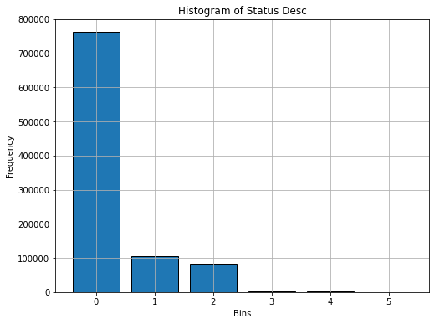 Here’s a histogram I made of status descriptions of arrests by the LA police. There are 6 possible values. Below are two histograms of the closest distributions generated by my code (Weibull and Chi Squared). You can see that the distributions are different in the 2nd and 3rd columns, but because the counts are so large, the test does not classify the actual data as belonging to either distribution. With smaller count values, the test overfits.
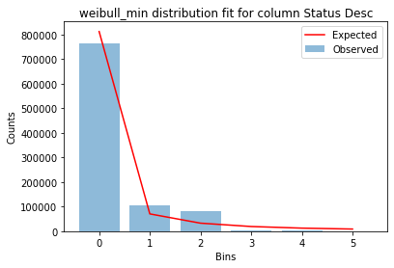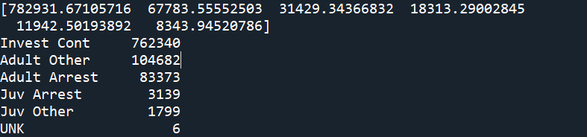
Expected counts (array) vs. observed counts for Weibull. You can see the difference.
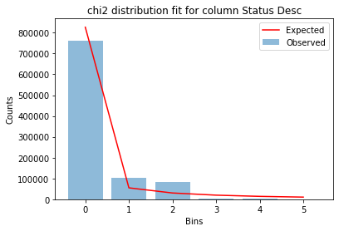
I tested my code on country names from the gdp dataset, status descriptions of arrests, and area codes of arrests, but they are not fit by any distributions. Lowering the p-value threshold does make it more likely that the test will correctly predict the distribution but it also increases the risk of false positives.
It might make more sense to just share the histogram of the data and have the user draw their own conclusions, especially because there’s not much you can do after you know the distribution of categorical data.
LLM Output:
https://chatgpt.com/share/ad9599f5-1467-41ee-9e97-2849fc4df84dChatGPT:
- Gets confused and attempts to analyze this data as if it was continuous.
- When I try to analyze it as a categorical dataset, it only checks mode and draws box-plot – doesn’t check that it’s normal.
- When I asked “what distribution best fits this data,” starts by using SSE to determine what distribution best fits the data. This approach will return at least one distribution even if it is a very poor fit. Then tries to run K-S on the data, which is not appropriate. Then has trouble even running a Chi-Squared test (maybe all the previous info made it confused).
  - That being said, if we want to return what distribution best fits the data, that is a different question than whether the data is likely to be drawn from a certain distribution. My code answers the latter question.
Copilot:
- Starts by analyzing the frequency of the counts of the data
- Cannot run the code but describes the chi-squared test
Julius:
- Tries to run K-S test on the counts of each categorical variable which would not be appropriate. (i.e. took the number of times each categorical variable was present as the dependent variable)
Overall:
- Visual methods still seem to be the best when analyzing the fit of distributions
- Categorical data seems to be difficult for models to analyze
- Can also add a test that finds the best distribution out of maybe 3-4 that fits the data – not sure whether this would be useful or not

Testing for various distributions:
- There are obviously many continuous distributions with many different possible parameters
  - What if you don’t know the parameters of your distribution? You can fit the distribution to your data to estimate parameters, then run K-S test, but that may lead to overfitting
  - Better solution is to bootstrap and use the bootstrapped version to estimate parameters
    - Could be more time-consuming, especially for larger datasets or when this process has to be repeated for many distributions
- Some tests that do not require parameters: exponential, normal, uniform
- Null hypothesis is that the data follows the distribution of choice – so you want the p-value to be greater than .05
- Majority of people recommend histograms/QQ plots to start – user can then perform statistical tests for further analysis on specific distributions
- Categorical data only has the chi squared goodness of fit test as an option
  - Doesn’t perform as well w/ less than 5 samples per category
  - Can be finicky as categories can be reordered in ways that may hide the underlying distribution – difficult to determine the exact distribution

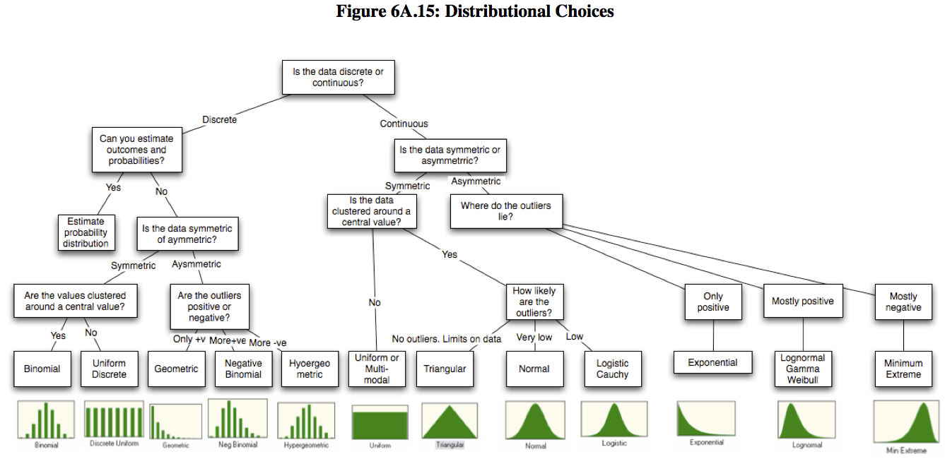
----------------------------------------------------------------------------------
Time series analysis:
- Looking for 50-60 data points before a meaningful forecast can be made
- Most popular models are ARIMA and Exponential Smoothing – depends on the data:
Anomaly detection for multivariate datasets:
- Isolation Forest, LOF, one-class SVM
- Isolation Forest (tree-based classification) seems to be one of the most used, along with LOF
  - iForest has a contamination argument that is by default set to ‘auto’, can be modified depending on the needs of the user (determines how much of the dataset can be classified as an outlier, further tests can determine how much impact these outliers actually have on the data)
    - No need to scale data
    - Robust to skewed/heavy-tailed data
  - LOF works well in low-dimensional feature space as it is a nearest neighbors based algorithm – suffers from the curse of high dimensionality
- Outliers may be useful to the model and in that case should be maintained and/or analyzed separately (as in the case of country data)

